
No: 5. 2013/14 Cropping Season October 21- 31, 2013

HIGHLIGHTS
- Early planted crops over LVB was affected by false start, thus the expected rains during third dekad of October, 2013 are beneficial for replanting and crop development over these areas mainly Kagera region and northern Kigoma
- Dry conditions continued over unimodal areas of the country are beneficial for land preparation

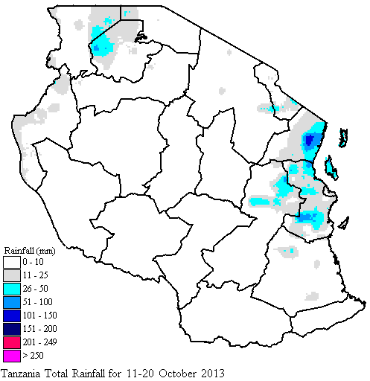

SYNOPTIC SUMMARY

D
uring the second dekad of October 2013, there was no significant change in strength of the northern hemisphere high pressure systems, the Azores and Siberian highs while in the southern hemisphere, the St. Helena high relaxed slightly while the Mascarene high intensified slightly. This generally maintained the ITCZ relatively to the north of Kenya. Low level convergence wind flow pattern was maintained throughout the period over the Lake Victoria Basin. On the other hand, most of the remaining parts of the country, particularly the eastern sector, were dominated by the relatively less moist south easterly wind flow.

WEATHER SUMMARY

The observed synoptic conditions during the dekad led to thundery activities with occasional cases of showers over the Lake Victoria basin. Occasional light rains over areas along the coast and the hinterlands in the northern coast. The highest amount of rainfall during the dekad was recorded at Amani-Marikitanda (93.3 mm), followed by Zanzibar (56.7 mm), Mlingano (48.7 mm), Kibaha (32.0 mm), and Tanga (28.4 mm). Figure 1 is the Geospatial Water Requirement Satisfaction Index (GeoWRSI) model with inputs from Satellite Rainfall Estimates (RFE) merged with gauge data from Tanzania rainfall stations network which also indicates similar pattern of the rainfall received during the dekad.
Much of bimodal areas in the northeastern highlands, Lake Victoria basin (LVB), and northern coast, the start of short rains (OND) in 2013 was expected in October but there had been a false start over LVB as indicated in Figure 1.

Figure 1: Rainfall amounts for October 11-20, 2013

IMPACT ASSESSMENT

Agrometeorological and Crop Summary

During the second dekad of October 2013,wet conditions that observed over parts of bimodal areas signify the commencement of short rain season (Vuli). The observed rainfall over Lake Victoria basin (Mwanza and Kagera), northern Kigoma, and other parts of northern coast (Dar es Salaam, Morogoro and Tanga Regions, and the isles of Unguja and Pemba) are good indications that the Vuli rains have started to set in. Farmers in these areas are planting while others weeding as reported over northern Kigoma and Kagera region. Over unimodal sector, land preparation was the major activity. Pastures and water availability for livestock and wildlife remain at low levels over much of the country.
Hydrological Summary
Water levels in dams and river-flow continued to decrease due to prevailing seasonal dry conditions over most parts of the country.

Environmental Summary
During the period temperature conditions over much of the country was at increasing trend.

EXPECTED SYNOPTIC CONDITIONS

DURING OCTOBER 21 -31, 2013

During the third dekad of October 2013, pressure systems over the northern hemisphere are expected to slightly intensify while their counterparts in the southern hemisphere are expected to slightly relax. On the other hand the moist south-easterly flow is expected to be maintained during the period. With this pattern, thundery shower activities are expected to be maintained over the Lake Victoria basin and enhanced over the western areas while persistence of rain showers are likely along the coast and its hinterlands. Other parts of the country are expected to experience mainly dry conditions. However, warm Sea Surface Temperature (SSTs) observed and expected to continue over the Somali coast and eastern coast of Madagascar are expected to delay activities over the coast and its hinterlands until few days before end of the dekad as this setting will prohibit moist easterlies from reaching the Tanzania coast.

EXPECTED WEATHER

DURING OCTOBER 21 - 31, 2013

Lake Victoria basin (Kagera, Geita, Mwanza, Mara, Simiyu, and Shinyanga regions): Frequent thundery showers are expected. Northern coast (Dar es Salaam, Morogoro and Tanga regions, the Isles of Unguja and Pemba): Light rain showers are expected over few areas.
Prepared by
TANZANIA METEOROLOGICAL AGENCY
3rd, 4th & 10 ^{th} Floors - Ubungo Plaza – Morogoro Road.
P.O. Box 3056 Tel. 255 -(0) 22 – 2460706-8 ; Fax: 255 - (0) 22 – 2460718 E-mail: (1) met@meteo.go.tz (2) agromet1_tz@meteo.go.tz
Dar es Salaam UNITED REPUBLIC OF TANZANIA

Northeastern highlands (Kilimanjaro, Arusha and Manyara regions): Occasional rain showers are expected. Western regions (Kigoma, Rukwa and Tabora regions): Mainly dry conditions are expected. However, a few showers and thunderstorms are likely over parts of Kigoma and Rukwa regions. Central areas (Dodoma and Singida regions): Mainly dry conditions are expected with slightly warmer temperatures. Southwestern highlands (Southern Rukwa, Katavi, Njombe, Iringa and Mbeya region): Mainly dry conditions, with few rain showers over high grounds of Mbeya and Njombe regions. Southern coast (Mtwara and Lindi regions) and southern region are expected to experience rain showers over few areas.

AGROMETEOROLOGICAL OUTLOOK DURING OCTOBER 21 - 31, 2013

Early planted crops over LVB was affected by false start, thus the expected rains during third dekad of October, 2013 are beneficial for replanting and crop development over these areas mainly Kagera region and northern Kigoma. Preparations for land and farm inputs should continue over rest of bimodal areas and planting should be carried out in areas where soil moisture is sufficient to support crop germination. Farmers over the unimodal sector are advised to continue with land preparations.

